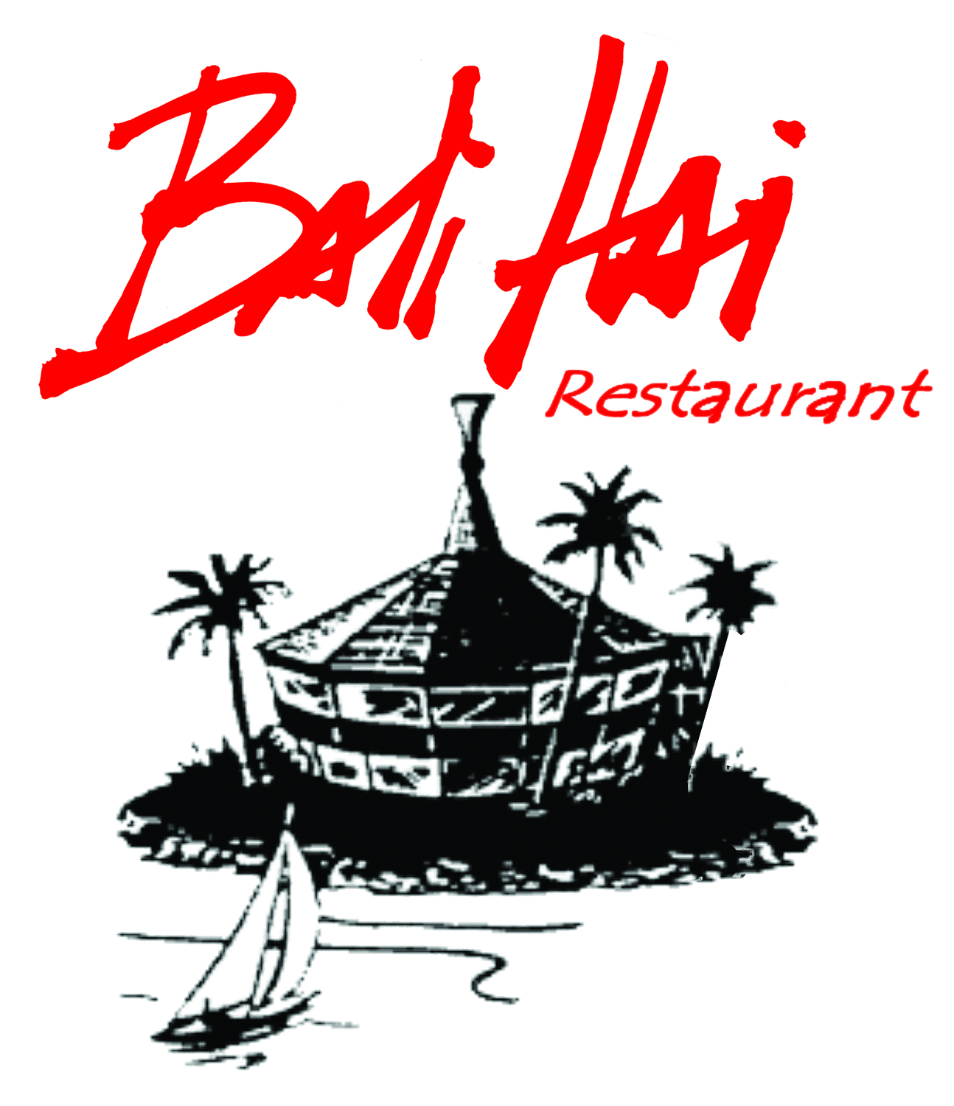

Contact: Sandy Young/ Jean Walcher, J. Walcher Communications
619-295-7140, sandy@jwalcher.com/ jean@jwalcher.com

Bali Hai Restaurant Reveals Fresh Bites on New Winter Menus

SAN DIEGO (January 25, 2013) – Creamy Lobster Risotto and Smoked Salmon Wontons are just two dishes debuting on the new winter lunch and dinner menus at Bali Hai Restaurant, San Diego’s iconic waterfront eatery on Shelter Island.

Executive Chef Dion Morales has introduced new appetizers and entrees to the Pacific Rim-inspired menu, including Sweet Onion Soup made with veal consommé, caramelized onion and served with Hawaiian bread fontina crostini, and Pork Shank with cauliflower puree, sesame pan sauce and Asian greens.

Other new items include Lobster Risotto with soft boiled egg, shiitake mushrooms, nori, shaved bonito and chives; Smoked Salmon Wontons with yuzu gastrique, sunomono and masago; and Spam and Pineapple Fried Rice.

“We have added new seasonal entrees to the menu to accompany old favorites like the Sweet & Sour Chicken and Seared Diver Scallops,” said Morales. “But, we have also enhanced some of our current dishes using new spices, sides and cooking techniques.”

For example, short ribs are now served with almond honey polenta, cocoa nibs and balsamic chocolate reduction. Adobo Duck Breast is paired with red cous cous, duck confit and pickled shishitos, and the Grilled Boneless Half Chicken features huli huli glaze, housemade “Spam” and char grilled scallions.

Morales has been with Bali Hai for 10 years, and was most recently the sous chef. He was named executive chef in late 2012.

For more information on the Bali Hai Restaurant, visit http://www.balihairestaurant.com. Bali Hai is open for lunch and dinner, Monday through Saturday; brunch and dinner on Sunday. Dinner reservations are recommended and can be made by calling 619-222-1181.

Bali Hai History
Opened in 1955 by San Diego restaurateur Tom Ham on the then newly constructed Shelter Island, Bali Hai was the island’s first “tiki temple,” named after the song popularized by the musical “South Pacific.” Two famous tiki icons were created for the structure: Mr. Bali Hai, a large wood sculpture at the front entrance greeting guests, and “The Goof,” a playful and mysterious remnant that stands guard on the roof of the restaurant.

Bali Hai has been family owned and operated for over five decades. Ham’s vision continues through his daughter Susie Baumann and her husband Larry. Sons Grant, Andy and Tommy Baumann, representing the third generation, have added a fresh, youthful influence, as well.

For more information on Bali Hai’s food, colorful history, and restyled restaurant and lounge, visit http://www.balihairestaurant.com or “like” us on Facebook and “follow” us on Twitter.

###

